Setup Ansible host and try to configure basic ping and shell modules on command line itself.



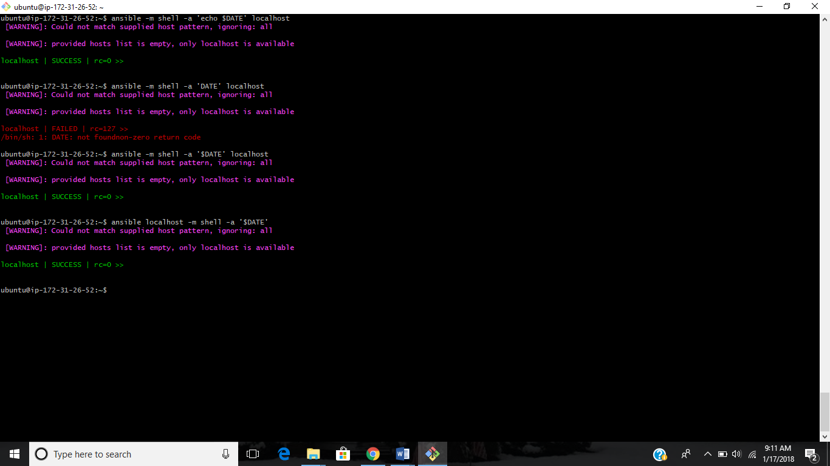

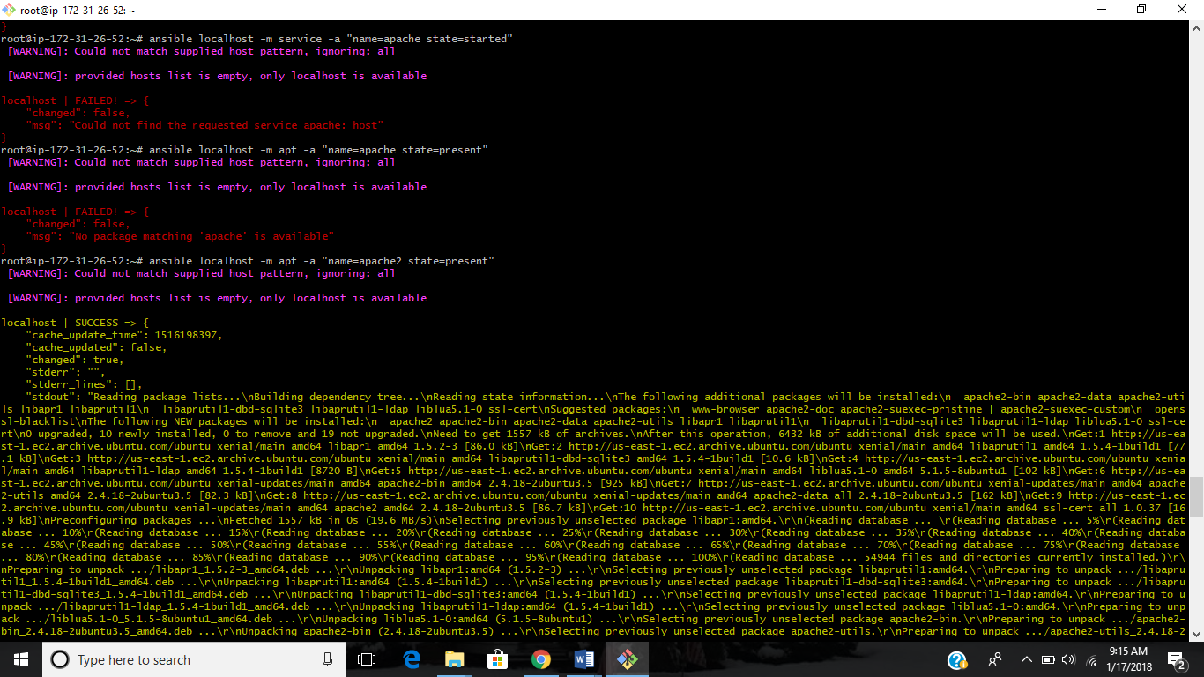

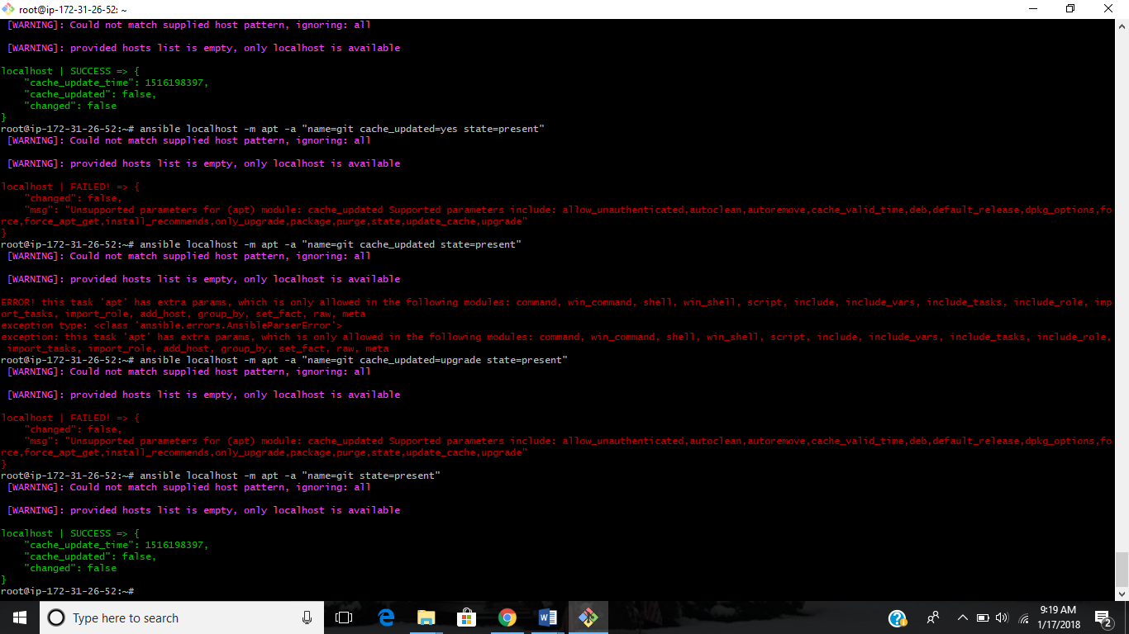

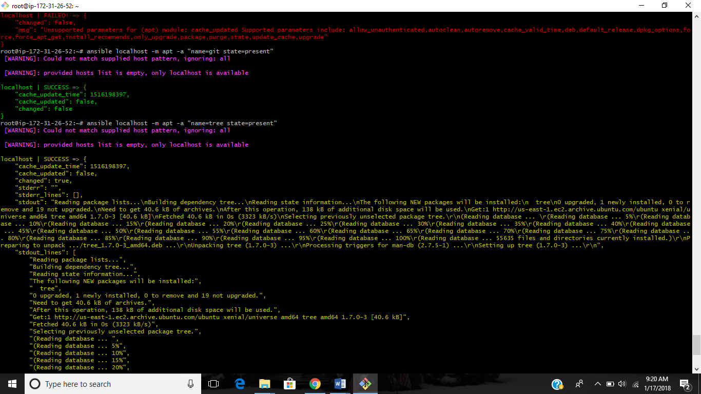

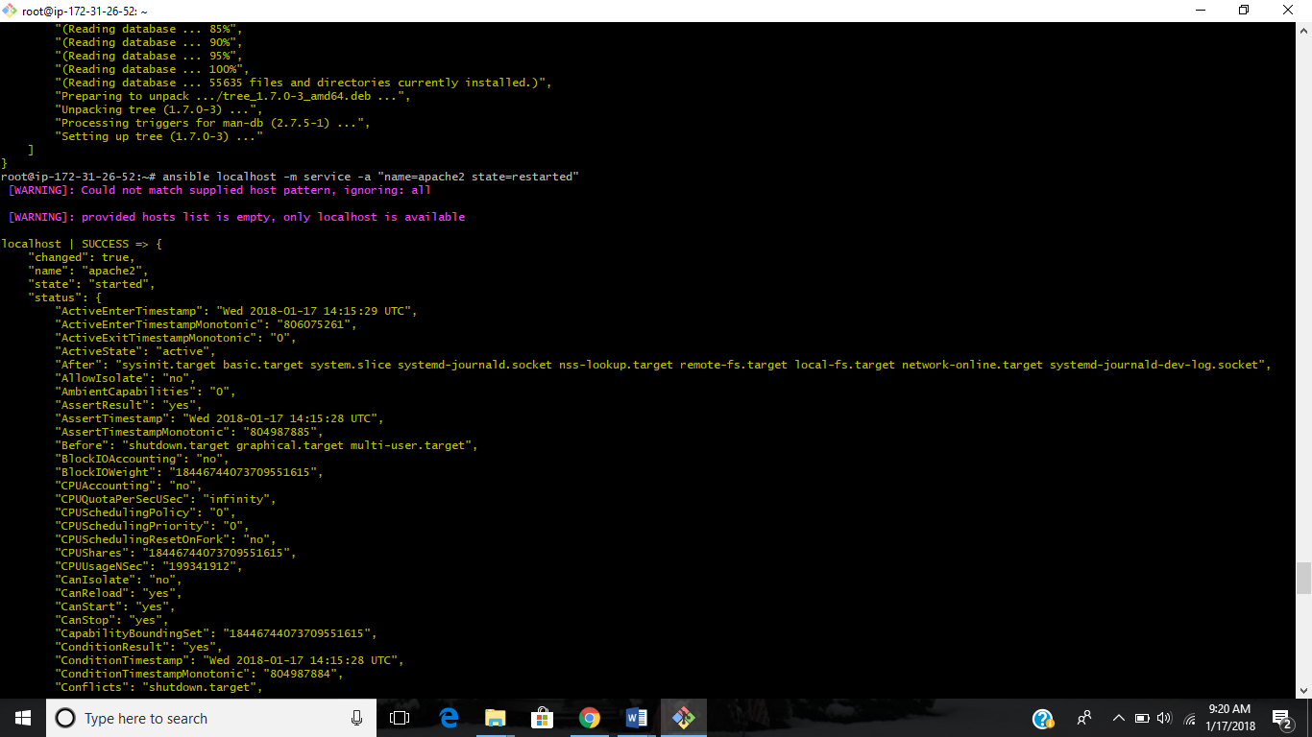



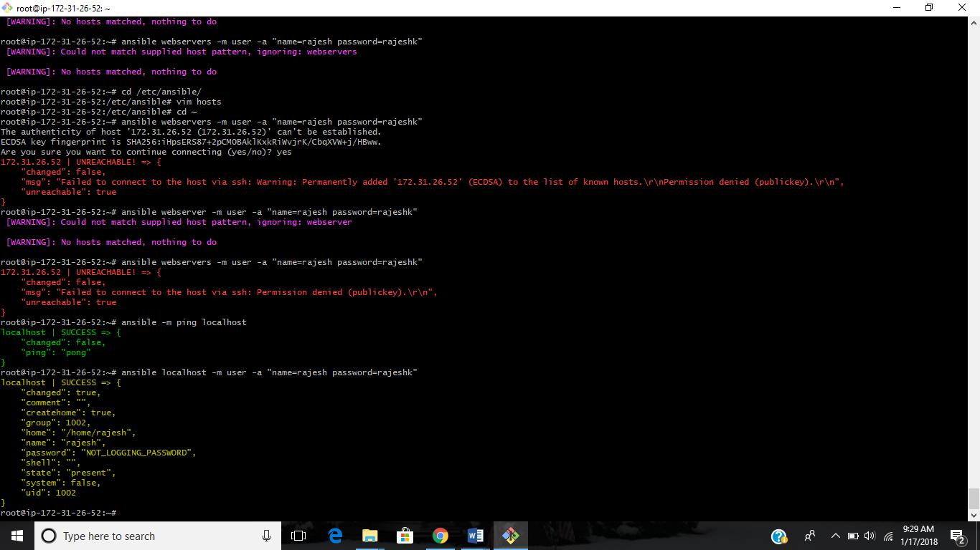

Hen try to create a basic playbook for installing Ubuntu/yum packages on server using basic Ansible playbook.

---

- hosts: localhost

- tasks:

- name: apache installation

yum: name=httpd state=present

---

- hosts: localhost

- tasks:

- name: apache latest version

yum: name=httpd state=latest

- handlers:

- name: restart apache

service: name=httpd state=restarted

---

- hosts: localhost

- tasks:

- name: install tree

apt: name=tree state=present

---

- hosts: localhost

- tasks:

- name: install git

apt: name=git state=present

---

- hosts: localhost

- tasks:

- name: install git latest

apt: name=git state=latest

- hosts: localhost

tasks:

- name: Install nginx

apt: name=nginx state=installed

- hosts: localhost

tasks:

- name: Install nginx

Yum: name=nginx state=installed

- hosts: localhost

tasks:

- name: Install nginx

yum=name=nginx state=installed

handlers:

- name: start nginx

service: name=nginx state=started

- name: Install latest version of "openjdk-6-jdk"

apt:

name: openjdk-6-jdk

state: latest